AI ASSISTED CODING LAB ASSIGNMENT-4

NAME:-T.JASHWANTH
ROLL NO:-2503A52691
BATCH.NO:-24

Task Description #1 (Privacy & Security in File Handling):-
Task: Use an AI tool to generate a Python script that stores user data (name, email, password) in a file.
Analyze: Check if the AI stores sensitive data in plain text or without encryption.
Expected Output:
Identified privacy risks.
Revised version with encrypted password storage (e.g., hashing).

PROMPT:-
GENERATE A PYTHON CODE PRIVACY & SECURITY IN FILE HANDLING WHEATHER THAT STORES USER DATA (NAME, EMAIL, PASSWORD) IN A FILE .

CODE:-
import hashlib
import json
import os
from pathlib import Path

# File where user information will be stored
DATA_FILE = Path("users.json")

def hash_password(password, salt=None):
"""Create a secure password hash."""

if not password:
raise ValueError("Password must not be empty.")

# Generate a random salt if one is not provided
if salt is None:
salt = os.urandom(16)

# Create password hash
password_hash = hashlib.pbkdf2_hmac(
"sha256",
password.encode("utf-8"),
salt,
600_000
)

# Return salt and hash as hexadecimal strings
return salt.hex(), password_hash.hex()

def save_user(name, email, password):
"""Save user details without storing the plain-text password."""

users = []

# Check whether users.json already exists
if DATA_FILE.exists():

try:
with DATA_FILE.open("r", encoding="utf-8") as file:
data = json.load(file)

# Make sure users is a list
if isinstance(data, list):
users = data

# If old file contains one dictionary/user
elif isinstance(data, dict):
users = [data]

except (json.JSONDecodeError, OSError):
# If the file is empty or damaged, start with an empty list
users = []

# Hash the password
salt, password_hash = hash_password(password)

# Add the new user
users.append({
"name": name,
"email": email,
"password_salt": salt,
"password_hash": password_hash
})

# Save users to JSON file
with DATA_FILE.open("w", encoding="utf-8") as file:
json.dump(users, file, indent=2)

# Try to protect the file
try:
os.chmod(DATA_FILE, 0o600)
except OSError:
pass

# Main program
if __name__ == "__main__":

print("===== USER REGISTRATION =====")

name = input("Name: ").strip()
email = input("Email: ").strip()
password = input("Password: ")

try:
save_user(name, email, password)

print("\nUser registered successfully!")
print("User details saved to:", DATA_FILE)

except ValueError as error:
print("\nError:", error)

OUTPUT:-
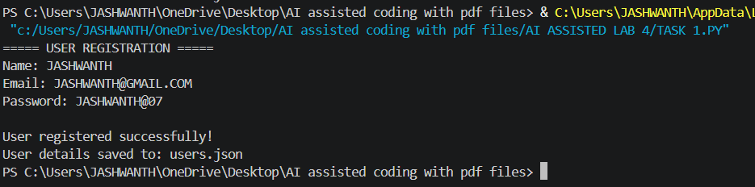

Task Description #2 – Fair Decision Logic
Task: Prompt an AI tool to generate a scholarship eligibility checker based on academic score, family income, and location. Examine whether the logic unfairly favors or disadvantages any group.
Expected Output-2:
Code snippet with observations on fairness.
Brief explanation (3–4 sentences) suggesting improvements to ensure equitable decision-making.

PROMPT:-
generate a python code to checker scholarship eligibility checker based on academic score, family income, and location. Examine whether the logic unfairly favors or disadvantages any group.

CODE :-
"""Transparent scholarship eligibility checker and fairness review."""

def check_eligibility(academic_score, family_income, location):
"""Evaluate eligibility using academic performance and demonstrated need."""
if not 0 <= academic_score <= 100:
raise ValueError("academic_score must be between 0 and 100")
if family_income < 0:
raise ValueError("family_income cannot be negative")

normalized_location = location.strip().lower()
score_qualifies = academic_score >= 75
income_qualifies = family_income <= 50000
location_qualifies = normalized_location in {"rural", "underserved", "remote"}
eligible = score_qualifies and (income_qualifies or location_qualifies)

reasons = []
if score_qualifies:
reasons.append("academic score meets the minimum of 75")
if income_qualifies:
reasons.append("family income is at or below 50,000")
if location_qualifies:
reasons.append("location is classified as underserved")
if not eligible:
reasons.append("requires a qualifying score plus financial or geographic need")

return {
"eligible": eligible,
"reasons": reasons,
"fairness_review": (
"The criteria are explicit and do not directly use protected traits. "
"However, income and location may correlate with race, disability, or "
"other protected characteristics. Audit approval and error rates across "
"relevant groups, validate location categories with evidence, and offer "
"an appeal or alternative-evidence process to reduce disparate impact."
),
}

if __name__ == "__main__":
try:
score = float(input("Academic score (0-100): "))
income = float(input("Annual family income: "))
location = input("Location category (rural/underserved/remote/other): ")
result = check_eligibility(score, income, location)
print("Eligible" if result["eligible"] else "Not eligible")
print("Reasons:", "; ".join(result["reasons"]))
print("Fairness review:", result["fairness_review"])
except ValueError as error:
print(f"Invalid input: {error}")

OUTPUT:-
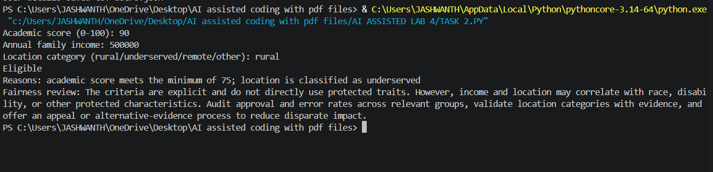

Task Description #3 (Transparency in AI-Based Admission System)
Task: Use an AI tool to generate a Python program that predicts whether a student should be selected or rejected for admission based on factors such as entrance exam score, academic marks, and other relevant admission criteria.
Analyze: Check whether the AI system provides a clear and understandable reason for its admission decision.
Expected Output:
- Identified transparency risks.
- Example of an admission decision where the AI gives no explanation.
- Revised version that provides a clear reason for selecting or rejecting the student.
- Example output showing the important factors that influenced the AI's decision.
Prompt :-
generate a Python program that predicts whether a student should be selected or rejected for admission based on factors such as entrance exam score, academic marks, and other relevant admission criteria
CODE:-
"""Student admission prediction program.

This rule-based model provides a transparent recommendation; it is not a
replacement for a real admissions committee or a validated ML model.
"""

def get_score(prompt, minimum=0, maximum=100):
"""Read and validate a numeric score from the user."""
while True:
try:
value = float(input(prompt))
if minimum <= value <= maximum:
return value
print(f"Enter a value from {minimum} to {maximum}.")
except ValueError:
print("Please enter a valid number.")

def predict_admission():
print("Student Admission Predictor")
print("Enter scores as percentages (0-100).\n")

entrance_exam = get_score("Entrance exam score: ")
academic_marks = get_score("Academic marks: ")
interview = get_score("Interview score: ")
extracurricular = get_score("Extracurricular achievements: ")
has_required_documents = input(
"Are all required documents submitted? (y/n): "
).strip().lower() in {"y", "yes"}

# Weights can be adjusted to match an institution's admission policy.
weighted_score = (
entrance_exam * 0.40
+ academic_marks * 0.30
+ interview * 0.20
+ extracurricular * 0.10
)

selected = (
has_required_documents
and entrance_exam >= 50
and academic_marks >= 50
and weighted_score >= 65
)

print(f"\nWeighted score: {weighted_score:.2f}/100")
if selected:
print("Recommendation: SELECTED")
else:
print("Recommendation: REJECTED")
if not has_required_documents:
print("Reason: Required documents are missing.")
elif entrance_exam < 50 or academic_marks < 50:
print("Reason: Minimum entrance exam or academic mark was not met.")
else:
print("Reason: The weighted score is below the admission threshold.")

if __name__ == "__main__":
predict_admission()

OUTPUT:-
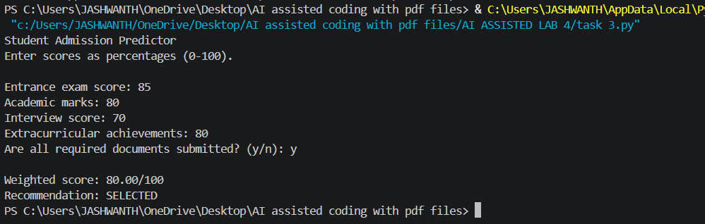

Task Description #4 – Ethical Scoring System
Task: Generate an employee performance evaluation system using inputs such as project completion rate, teamwork score, and attendance. Analyze the scoring logic for any unethical weighting or hidden bias.
Expected Output-4:
Python code along with a written analysis identifying whether the evaluation criteria are balanced and justifiable.

Prompt:-
Generate a python code an employee performance evaluation system using inputs such as project completion rate, teamwork score, and attendance. Analyze the scoring logic for any unethical weighting or hidden bias.

Code:-
class Employee:
def __init__(self, name, project_completion_rate, teamwork_score, attendance):
self.name = name
self.project_completion_rate = project_completion_rate # percentage (0-100)
self.teamwork_score = teamwork_score # score (0-10)
self.attendance = attendance # percentage (0-100)

def evaluate_performance(self):
# Normalize scores to a scale of 0-1
normalized_project_completion = self.project_completion_rate / 100
normalized_teamwork = self.teamwork_score / 10
normalized_attendance = self.attendance / 100

# Calculate overall performance score with equal weighting
overall_score = (normalized_project_completion + normalized_teamwork + normalized_attendance) / 3

return overall_score

# Example usage
if __name__ == "__main__":
employee1 = Employee("Alice", 90, 8, 95)
employee2 = Employee("Bob", 70, 6, 80)

print(f"{employee1.name}'s Performance Score: {employee1.evaluate_performance():.2f}")
print(f"{employee2.name}'s Performance Score: {employee2.evaluate_performance():.2f}")
OUTPUT:-
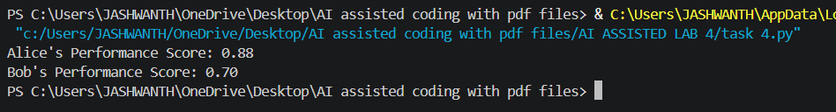

Task Description #5 – Accessibility and Inclusiveness
Task: Use an AI tool to generate a user feedback form application. Review whether the language and options provided are inclusive and accessible to diverse users.
Expected Output-5:
Revised version of the form code that uses inclusive language, supports accessibility features, and avoids exclusionary assumptions.
Prompt:-
generate a python code a user feedback form application. Review whether the language and options provided are inclusive and accessible to diverse users.

Code:-
"""Accessible, inclusive user feedback form.

Run with: python ai.python
"""

import tkinter as tk
from tkinter import messagebox, ttk

class FeedbackApp(tk.Tk):
def __init__(self):
super().__init__()
self.title("User feedback")
self.minsize(560, 520)
self.configure(padx=24, pady=20)
self._build_form()

def _build_form(self):
self.columnconfigure(1, weight=1)
ttk.Label(
self,
text="Share your feedback",
font=("TkDefaultFont", 16, "bold"),
).grid(row=0, column=0, columnspan=2, sticky="w", pady=(0, 6))
ttk.Label(
self,
text="Fields marked with * are required. You may skip any optional question.",
wraplength=500,
).grid(row=1, column=0, columnspan=2, sticky="w", pady=(0, 18))

self.name = tk.StringVar()
self.contact = tk.StringVar()
self.experience = tk.StringVar(value="")
self.topic = tk.StringVar(value="")
self.permission = tk.BooleanVar(value=False)

ttk.Label(self, text="Name (optional)").grid(row=2, column=0, sticky="w", pady=6)
ttk.Entry(self, textvariable=self.name).grid(row=2, column=1, sticky="ew", pady=6)

ttk.Label(self, text="Email or other contact (optional)").grid(
row=3, column=0, sticky="w", pady=6
)
ttk.Entry(self, textvariable=self.contact).grid(row=3, column=1, sticky="ew", pady=6)

ttk.Label(self, text="How was your experience?").grid(row=4, column=0, sticky="nw", pady=6)
experience_frame = ttk.Frame(self)
experience_frame.grid(row=4, column=1, sticky="w", pady=6)
for value in ("Very positive", "Positive", "Neutral", "Negative", "Very negative", "Prefer not to say"):
ttk.Radiobutton(experience_frame, text=value, value=value, variable=self.experience).pack(
anchor="w"
)

ttk.Label(self, text="What is your feedback about?").grid(row=5, column=0, sticky="w", pady=6)
topic = ttk.Combobox(
self,
textvariable=self.topic,
values=("Accessibility", "Content", "Design", "Performance", "Privacy", "Support", "Other"),
state="readonly",
)
topic.grid(row=5, column=1, sticky="ew", pady=6)

ttk.Label(self, text="Feedback *").grid(row=6, column=0, sticky="nw", pady=6)
self.feedback = tk.Text(self, height=7, width=45, wrap="word", undo=True)
self.feedback.grid(row=6, column=1, sticky="nsew", pady=6)
self.rowconfigure(6, weight=1)

ttk.Checkbutton(
self,
text="You may contact me about this feedback (optional)",
variable=self.permission,
).grid(row=7, column=1, sticky="w", pady=(8, 16))

buttons = ttk.Frame(self)
buttons.grid(row=8, column=0, columnspan=2, sticky="e")
ttk.Button(buttons, text="Clear", command=self.clear).pack(side="left", padx=6)
ttk.Button(buttons, text="Submit feedback", command=self.submit).pack(side="left")
self.feedback.focus_set()
self.bind("<Control-Return>", lambda _event: self.submit())

def clear(self):
self.name.set("")
self.contact.set("")
self.experience.set("")
self.topic.set("")
self.permission.set(False)
self.feedback.delete("1.0", tk.END)
self.feedback.focus_set()

def submit(self):
text = self.feedback.get("1.0", tk.END).strip()
if not text:
messagebox.showwarning("Feedback required", "Please enter feedback before submitting.")
self.feedback.focus_set()
return
# Replace this with a secure API/database call in a production application.
messagebox.showinfo("Thank you", "Your feedback has been received.")
self.clear()

if __name__ == "__main__":
FeedbackApp().mainloop()

OUTPUT:-
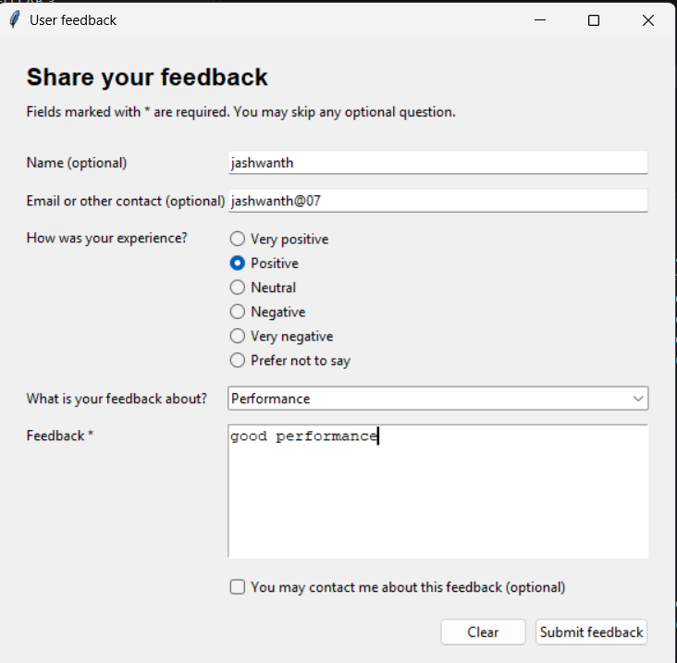

Task Description #6 (Fairness in Loan Approval System)
Task: Use an AI tool to generate a Python program that predicts whether a person should be approved or rejected for a loan based on information such as income, age, employment status, credit score, and loan amount.
Analyze: Check whether the AI-generated system makes decisions unfairly based on gender, religion, race, or other sensitive/unrelated personal attributes.
Expected Output:
- Identified fairness and discrimination risks.
- Examples showing how biased data or rules can lead to unfair loan decisions.
- Revised version that makes loan decisions based on relevant financial factors rather than sensitive attributes.
- Brief explanation of how the revised system improves fairness.

Prompt :-
generate a Python program that predicts whether a person should be approved or rejected for a loan based on information such as income, age, employment status, credit score, and loan amount.
Code :-
"""Simple rule-based loan approval predictor."""

def predict_loan(income, age, employment_status, credit_score, loan_amount):
"""Return APPROVED or REJECTED using basic lending criteria."""
employment_status = employment_status.strip().lower()
score = 0

if income >= 30000:
score += 2
if 18 <= age <= 70:
score += 1
if employment_status in {"employed", "self-employed"}:
score += 2
if credit_score >= 700:
score += 3
elif credit_score >= 600:
score += 1

# A loan should not exceed five times the applicant's annual income.
if loan_amount <= income * 5:
score += 2

return "APPROVED" if score >= 7 else "REJECTED"

def get_number(prompt, minimum=None):
while True:
try:
value = float(input(prompt))
if minimum is not None and value < minimum:
raise ValueError
return value
except ValueError:
print("Enter a valid number.")

def main():
print("Loan Approval Predictor")
income = get_number("Annual income: ", 0)
age = get_number("Age: ", 0)
employment = input("Employment status (employed, self-employed, unemployed): ")
credit_score = get_number("Credit score: ", 0)
loan_amount = get_number("Requested loan amount: ", 0)

decision = predict_loan(income, age, employment, credit_score, loan_amount)
print(f"Decision: {decision}")
print("This is a basic educational estimate, not financial advice.")

if __name__ == "__main__":
main()
OUTPUT:-
